

**RETAIL AND VENDOR**

**SYSTEM USING DIFFUSING**

**UPDATE ALGORITHM**

# **PROJECT REPORT**

***Submitted by***

|  |  |
| --- | --- |
| **SANJAY P** | **611220104125** |
| **SINDIYAA TV** | **611220104141** |
| **SOWMIYA K** | **611220104147** |
| **VINISH V** | **611220104171** |

***in partial fulfilment for the award of the degree***

***of***

**BACHELOR OF ENGINEERING**

**IN**

**COMPUTER SCIENCE AND ENGINEERING**

**KNOWLEDGE INSTITUTE OF TECHNOLOGY,**

**SALEM-637504**

**ANNA UNIVERSITY::CHENNAI 600 025**

**MAY 2023**



**RETAIL AND VENDOR**

**SYSTEM USING DIFFUSING UPDATE ALGORITHM**

# **PROJECT REPORT**

***Submitted by***

|  |  |
| --- | --- |
| **SANJAY P** | **611220104125** |
| **SINDIYAA TV** | **611220104141** |
| **SOWMIYA K** | **611220104147** |
| **VINISH V** | **611220104171** |

***in partial fulfilment for the award of the degree***

***of***

**BACHELOR OF ENGINEERING**

**IN**

**COMPUTER SCIENCE AND ENGINEERING**

**KNOWLEDGE INSTITUTE OF TECHNOLOGY**

**SALEM-637504**

**ANNA UNIVERSITY::CHENNAI 600 025**

**MAY 2023**

# **ANNA UNIVERSITY::CHENNAI 600 025**

**BONAFIDE CERTIFICATE**

Certified that this project report titled **“RETAIL AND VENDOR SYSTEM USING DIFFUSING UPDATE ALGORITHM”** is the bonafide work of **“SANJAY P (611220104125), SINDIYAA TV (611220104141), SOWMIYA K (611220104147), VINISH V (611220104171)”** who carried out the project work under my supervision.

**SIGNATURE**  **SIGNATURE**

Dr. V. KUMAR M.E., Ph.D., Mrs. D. RAMYA B.Tech., M.E.,

**HEAD OF THE DEPARTMENT** **SUPERVISOR**

**PROFESSOR** **ASSISTANT PROFESSOR**

Department of Computer Science Department of Computer Science

and Engineering, and Engineering,

Knowledge Institute of Technology, Knowledge Institute of Technology,

Kakapalayam, Kakapalayam,

Salem- 637 504. Salem- 637 504.

Submitted for the Project Viva-Voce Examination held on _____________

--------------------------- ---------------------------

INTERNAL EXAMINER EXTERNAL EXAMINER

# **ACKNOWLEDGEMENT**

At the outset, we express our heartfelt gratitude to **GOD,** who has been our strength to bring this project to light.

At this pleasing moment of having successful completed our project, we wish to convey our sincere thanks and graduate to our beloved president **Mr. C. BALAKRISHNAN,** who has provided all facilities to us.

We would like to convey our sincere thanks to our beloved principal **Dr. PSS. SRINIVASAN,** for forwarding us to do our project and offering adequate duration in completing our project.

We express our sincere thanks to our Head of the Department

**Dr. V. KUMAR,** Department of Computer science and Engineering for fostering the excellent academic climate in our department.

We express our pronounced sense of thanks with deepest respect and gratitude to our project guide **Mrs. D. RAMYA,** Assistant professor Computer science and Engineering Department, for her valuable and precious guidance and for having amicable relation.

With deep sense of gratitude, we extend our earnest and sincere thanks to our project coordinator **Mrs. M. JEEVA,** Assistant professor, Department of Computer science and Engineering for her guidance and encouragement during this project.

We would also like express our thanks to all the faculty members of our department, friends and students who helped us directly and indirectly in all aspects of the project work to get completed successfully.

# **TABLE OF CONTENT**

|  |  |  |
| --- | --- | --- |
| **CHAPTER**  **NO** | **TITLE** | **PAGE**  **NO** |
|  | **ABSTRACT** | **I** |
|  | **LIST OF FIGURES** | **II** |
|  | **LIST OF ABBREVATIONS** | **III** |
| **1** | **INTRODUCTION** | **1** |
|  | 1.1 INTRODUCTION | 1 |
| **2** | **SYSTEM ANALYSIS** | **2** |
|  | 2.1 EXISTING SYSTEM | 2 |
|  | 2.2 PROBLEM IDENTIFICATION | 2 |
|  | 2.3 PROPOSED SYSTEM | 3 |
| **3** | **SYSTEM SPECIFICATION** | **4** |
| **4** | **SYSTEM DESIGN** | **5** |
|  | 4.1 SYSTEM ARCHITECTURE | 5 |
|  | 4.2 BLOCK DIAGRAM | 6 |
| **5** | **MODULE DESCRIPTION** | **7** |
|  | 5.1 MODULES | 7 |
|  | 5.1.1 Retail Module | 7 |
|  | 5.1.1.1 Centralized Inventory  Management | 8 |
|  | 5.1.1.2 Point-Of-Sale Integration | 8 |
|  | 5.1.1.3 Customer Relationship  Management | 9 |
|  | 5.1.1.4 Staff Management | 9 |
|  | 5.1.2 Vendor Module | 10 |
|  | 5.1.2.1 Web Server | 10 |
|  | 5.1.2.2 Client Details | 11 |
| **6** | **SYSTEM TESTING** | **12** |
|  | 6.1 TYPES OF TESTING | 12 |
|  | 6.1.1 Message Passing Testing | 13 |
|  | 6.1.2 Ping Testing | 14 |
|  | 6.1.3 Firewall Testing | 15 |
| **7** | **SYSTEM IMPLEMENTATION** | **17** |
| **8** | **CONCLUSION AND FUTURE ENHANCEMENT** | **18** |
|  | 8.1 CONCLUSION | 18 |
|  | 8.2 FUTURE ENHANCEMENT | 18 |
| **9** | **APPENDIX** | **A1** |
|  | A.1 COMMANDS | A1 |
|  | A.2 SCREENSHOTS | A4 |
| **10** | **REFERENCE** | R1 |

# ABSTRACT



# **ABSTRACT**

The rise of digital technologies has revolutionized the retail industry, transforming the way business operate and interact with their customers. In this context, network retail shops have emerged as a powerful concept, leveraging networks to enhance customer reach, operational efficiency, and overall business performance. This explores the concept of a network between retail and vendor. A network retail shop refers to a business model that leverages a network of interconnected retail shops to amplify its presence and provide a seamless shopping experience to customers. The abstract further delves into the strategies and tactics employed by network retail shops to maximize their impact. One of the key strategies is establishing a connection between all the subdivisions in the system. In this system we have separated the whole system into two main division. Retail and Vendor, where retail contains four modules. Vendor consists of two modules. With use of HTTP, DNS, FTP, DHCP, EIGRP protocols this system is constructed. The use of servers and databases with high authentication makes the system highly secure. The access control for the servers is designed in such a way so that no others can change or access the data. so that the correct data is earned via this network system.

# **LIST OF FIGURES**

|  |  |  |
| --- | --- | --- |
| **FIGURE**  **NO** | **NAME OF THE FIGURE** | **PAGE**  **NO** |
| **4.1.1** | SYSTEM ARCHITECTURE OF RETAIL AND VENDOR SYSTEM | 5 |
| **4.2** | BLOCK DIAGRAM OF RETAIL AND VENDOR SYSTEM | 6 |
| **6.1.1** | MESSAGE PASSING TESTING SUCCESSFULL | 13 |
| **6.1.2** | PING TESTING SUCCESSFUL | 14 |
| **6.1.3** | FIREWALL TESTING SUCCESSFULL | 15 |

# **LIST OF ABBREVATIONS**

|  |  |
| --- | --- |
| **ABBREVATION** | **EXPANSION** |
| **CIM** | CENTRALIZED INVENTORY MANAGEMENT |
| **CRM** | CUSTOMER RELATIONSHIP MANAGEMENT |
| **POS** | POINT OF SALE |
| **FTP** | FILE TRANSFER PROTOCOL |
| **HTTP** | HYPER TEXT TRANSFER PROTOCOL |
| **DNS** | DOMAIN NAME SYSTEM |
| **DHCP** | DYNAMIC HOST CONFIGURATION |
| **EIGRP** | ENHANCED INTERIOR GATEWAY ROUTING PROTOCOL |

# INTRODUCTION

# **CHAPTER - 1**

**INTRODUCTION**

## **INTRODUCTION**

Business and sales have become major industries in today's developing era. A few decades before sales and business are not at that much peak. But today retailing place a vital role. Increasing the security and the management of the retail system is a crucial task. Proper networking between each and every segment increases the scope for this system. In this project we have two main modules, namely retail and vendor subsystems. Retail module consists of 4 submodules. Vendor module consists of 2 submodules. These client details are completely connected to a firewall system.

The first submodule CIM module ensures efficient operations and seamless customer experiences. The second submodule POS integration management system is a vital component of the network retail shop system, facilitating seamless and efficient transactions at the point of purchase. The third submodule CRM enables retailers to effectively manage and nurture relationships with their customers across the network of retail stores. Integrating CRM into the system offers several advantages and enhances the overall customer experience. In The fourth submodule Staff management ensures the workforce is effectively managed and aligned with the goals and operations of the retail network. Last submodule is client details are paramount considerations in the network retail shop system to safeguard sensitive data, protect the system from unauthorized access, and ensure compliance with privacy regulations. Implementing robust security measures and access control mechanisms within the system is crucial for maintaining the integrity and confidentiality of information.

# SYSTEM ANALYSIS

# **CHAPTER - 2**

**SYSTEM ANALYSIS**

## **2.1 EXISTING SYSTEM**

The already existing system in the network has too many complications. System crashes, slow performance, or software bugs can disrupt the normal functioning of the system, leading to delays and errors in operations. It is not properly integrated with other systems such as inventory management, point of sale (POS), or customer relationship management (CRM), it can result in data discrepancies, inefficient processes, and poor customer experience. Inadequate security measures can make the system susceptible to cyberattacks, data breaches, or unauthorized access. This can result in compromised customer information, financial loss, and damage to the reputation of the business. In that retail module itself it has two routers associated with it. even though there is no need of using two routers in the system. One router is connected to a firewall. But firewall protection for the retail module is not necessary. The main data that is to be secured is associated with the vendor module. connecting firewall to the retail module is not necessary and waste of cost. Instead of using two routers, which leads to more cost, we have huge opportunities to reduce the routers count and make the system more efficient.

## **2.2 PROBLEM IDENTIFICATION**

The already existing system consists of two routers and an unnecessary firewall. Two routers are not needed for the proper functionality of the system. These two routers and firewall lead to more cost and make the system more complex. The web integration and designing of the system is not that much efficient and interactive to the user. Security of the data is also not that much efficient in the already existing system. The firewall in the already existing system is connected to unnecessary module that need not any data security measures instead of data which need security measures.

## **2.3 PROPOSED SYSTEM**

In our system the whole system has only 2 routers. One router from retail module and other from vendor module. The router from the vendor module is connected to the retail module. so that we can minimize the cost for routers by this kind of router connection. The router connection from vendor module to retail module makes the efficient and simplex way of communication the system and reduces the complexity of the system. Firewall is connected to the vendor server to secure the client data. In this way our system is more efficient than the existing one. It reduces the cost of the system and the essential data secured with a highly secured firewall configuration. For making the system more interactive with the user's dynamic host configuration protocol plays a vital role. Adding mobile compatibility allows managers and employees to access from smartphones and tablets, enabling them to perform tasks on the go, such as checking inventory, placing orders, or reviewing sales data makes the system very interactive.

# SYSTEM SPECIFICATION

# **CHAPTER - 3**

**SYSTEM SPECIFICATION**

## **4.1 HARDWARE REQUIREMENTS**

Processor : AMD Ryzen5 345OU

RAM : 8 GB

## **4.2 SOFTWARE REQUIREMENTS**

Operating System : Windows

Program – Tool : Packet Tracer

## **4.3 TOOL REQUIREMENTS**

Operating System : Windows 11/10

Disk Size : 256 MB

Packet Tracer : 8.21

# SYSTEM DESIGN

# **CHAPTER – 4**

**SYSTEM DESIGN**

System design is the mechanism from a set of system requirements detected to a design that meets those requirements. It is the system that bridges the gap in a sustainable way between the problem area and the existing system. The whole network is divided into small networks and finally integrated with each other to form a whole system that works efficiently.

## **4.1 SYSTEM ARCHITECTURE**

Here the main routers of the retail and vendor module are connected through two switches on either side. The retail system has a single server for all the four sub modules. All the data in the CIM system, POS system, CRM system and staff management system are stored and processed through this single server. In the vendor module one server is connected to a web service system and the other server is connected to a security and access control system to protect the system data and authentication. Further the required number of PCs are connected to each sub module to manage the task.

### **4.1.1 Modules in the System**

1. Retail Module

1. Centralized Inventory Management (CIM)
2. Point-of-Sale Integration
3. Customer Relationship Management (CRM)
4. Staff Management

2. Vendor Module

1. Web service
2. Client detail

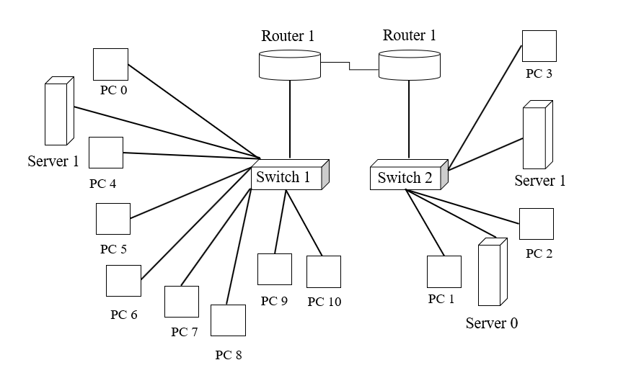

**Fig 4.1.1 SYSTEM ARCHITECTURE OF RETAIL AND VENDOR SYSTEM**

## **4.2 BLOCK DIAGRAM**

Retail and vendor system is the connection of retail and vendor. The block diagram clearly shows that every sub system is interconnected with each other. All the system is connected to a DNS server. It enables hostname resolution, load balancing, high availability, service discovery, and security. FTP server relates to four modules CIM system, POS integration, CRM, staff management. FTP server enables centralized file storage, data backup, recovery, security and access control. Finally, the client details are connected to a firewall. It monitors incoming and outgoing network traffic, filtering and blocking potentially malicious or unauthorized access attempts. Firewall provides additional security features, access control, and performance optimization. By deploying a firewall, retailers can safeguard their network, sensitive data.

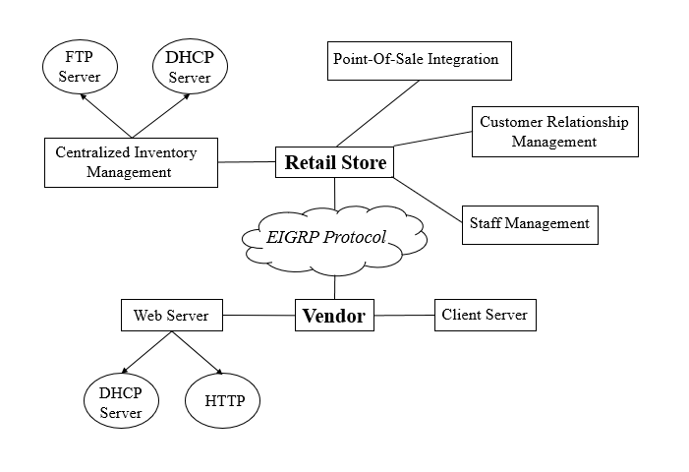

**Fig 4.2 BLOCK DIAGRAM OF RETAIL AND VENDOR SYSTEM**

# MODULE DESCRIPTION

# **CHAPTER - 5**

**MODULE DESCRIPTION**

## **5.1 MODULES**

**5.1.1 RETAIL MODULE**

1. Centralized Inventory Management (CIM)
2. Point-of-Sale Integration
3. Customer Relationship Management (CRM)
4. Staff Management

**5.1.2 VENDOR MODULE**

1. Web service
2. Client detail

## **5.1.1 Retail Module**

The retail module in network retail management refers to the specific component or set of functionalities within the overall system that focuses on managing the day-to-day operations and activities related to retail sales. It typically includes features and capabilities that support various aspects of the retail process such as Point of Sale (POS), Product Management, Inventory Management, Promotions and Pricing, Sales Reporting and Analytics, Customer Management, Returns and Refunds, Gift Cards and Vouchers, Multi-Channel Integration, Integration with Backend Systems.

### **5.1.1.1 Centralized Inventory Management**

CIM tracks the movement of products across various locations, providing real-time updates on stock levels, item availability, and location-specific details. Stock Replenishment is done by monitoring inventory levels and triggers automatic reordering or replenishment of products when predefined thresholds are reached, ensuring optimal stock levels are maintained. Centralized Stock Control enables centralized control and management of inventory across all stores, allowing for consistent stock management practices, pricing, promotions, and product information. FTP and DHCP protocols are used here. CIM is connected to the main server. Server type is PT and server number is 2. two PCs PC0 and PC4 are connected to CIM. These two PCs provided all the services and communicate with the server.

### **5.1.1.2 Point-Of-Sale Integration**

POS integration ensures that real-time inventory updates are reflected accurately across all channels, including online and offline sales. As the heartbeat of every retail operation, this powerful module empowers store associates to effortlessly handle transactions, access real-time product information, and create memorable shopping experiences. This enables retailers to have a comprehensive view of their inventory levels, prevent overselling, and streamline the reordering process. By integrating the POS system with the central product database, retailers can ensure that product information, such as descriptions, prices, and promotions, remains consistent across all sales channels. It enables retailers to analyze performance, and generate reports for better decision-making. Integrated payment processing ensures smooth and secure transactions, accommodating various payment methods. POS connected to the main server by PC5 namely PC5 and PC4.

### **5.1.1.3 Customer Relationship Management**

Customer Relationship Management (CRM) functionality, when integrated with the connection of an FTP (File Transfer Protocol) server, can enhance the capabilities of a network retail system. It also improves customer data management, enables targeted marketing campaigns, streamlines order management, enhances customer service, facilitates data synchronization and backup, and strengthens data analytics and reporting capabilities. CRM systems provide tools for planning, executing, and tracking marketing campaigns. By integrating CRM with an FTP server, retailers can exchange customer service-related files, such as documentation, product manuals, or troubleshooting guides. The CRM is connected with 2 PCs namely PC and PC8.

### **5.1.1.4 Staff Management**

With the help of staff management module, network retail management system efficiently manages staff scheduling, time and attendance tracking, communication, performance management, training, payroll, compliance, and reporting. It enables retailers to optimize workforce utilization, improve employee engagement, and enhance overall operational efficiency. By integrating staff management functionality with DNS and FTP servers, a network retail management system can enhance employee authentication, directory access, file sharing, automated backups, reporting, security, workflow automation, data synchronization, and integration capabilities. These integrations optimize staff management processes, improve data accessibility, and enhance overall system efficiency in the retail environment. Integrating staff management with DNS allows for seamless authentication and access control. Staff management module is connected to 2 PCs namely PC9 and PC10.

## **5.1.2 Vendor Module**

The vendor module in a network retail management system is a dedicated component that focuses on managing interactions and relationships with vendors or suppliers. It facilitates various processes related to vendor management, procurement, and supplier collaboration within the retail network. The vendor module typically includes the functionalities such as Vendor Database, Vendor Onboarding, Product Catalog Management, Purchase Order Management, Supplier Collaboration, Performance Tracking, Pricing and Contract Management, Vendor Payments and Invoicing, Vendor Analytics and Reporting, Integration with Supply Chain. It also has two sub modules connected, they are web service system, security and control access. It is connected to a router 2811 and a switch of configuration 2950T. Each sub module is connected to an individual server to store and authenticate the data.

### **5.1.2.1 Web Server**

Web servers form the backbone of the web infrastructure, delivering web content to clients and enabling dynamic interactions. Their functionalities play a crucial role in processing requests, serving static and dynamic content, ensuring security, scalability, and performance of web applications. It provides the necessary functionality to handle and respond to client requests. Here are some key functionalities of a web server such as HTTP Protocol Handling, Routing and URL Mapping, Static Content Delivery, Dynamic Content Generation, Application Server Integration, Load Balancing and Scalability, Caching, Virtual Hosting, Redirection and URL Rewriting. Web server is connected to server0. DNS and HTTP are the two protocols used in web servers. Two PCs, namely PC1 and PC2 are connected to web server.

### **5.1.2.2 Client Details**

The client details module in a network retail management system is responsible for managing and storing information related to the retail customers. It includes functionalities that capture, store, and track customer details to support personalized experiences, customer relationship management, and targeted marketing efforts. are some key functionalities of the client details module such as Customer Database, Customer Registration and Onboarding, Customer Segmentation, Purchase History and Order Tracking, Loyalty Program Management, Customer Communication and Engagement, Customer Service Integration, Customer Analytics and Reporting, Consent Management and Data Privacy, Integration with Sales Channels. This client details module is connected to server1. It has a single PC3 connected to it. Both have firewall connections to authenticate user data.



# SYSTEM TESTING

# **CHAPTER – 6**

**SYSTEM TESTING**

Testing in networks refers to the process of evaluating and verifying the performance, functionality, and reliability of network components, protocols, and systems. It involves conducting a series of tests to identify potential issues, validate network behavior, and ensure that the network operates as intended. The goal of network testing is to assess various aspects of the network infrastructure, including its ability to handle data transmission, maintain stable connections, and effectively route traffic. By performing comprehensive network testing, organizations can identify and address potential vulnerabilities, optimize network performance, and provide a secure and seamless experience for users.

Network testing plays a critical role in optimizing network infrastructure, identifying potential weaknesses or bottlenecks, and ensuring that the network meets the organization's requirements for performance, security, and reliability. By conducting thorough testing, network administrators can proactively address issues, improve network performance, and provide a stable and efficient network environment for users.

## **6.1 TYPES OF TESTING**

1. MESSAGE PASSING TESTING
2. PING TESTING
3. FIREWALL PROTECTION

### **6.1.1 Message Passing Testing**

Message passing testing in a network retail management system involves validating the communication and exchange of messages between different components or modules within the system. It ensures that the messages are transmitted accurately and timely, and that the system components can effectively send and receive information.

It verifies that the messages sent between system components adhere to the defined structure, including the correct format, encoding, and any required fields. It tests the routing functionality to ensure that messages are correctly directed to their intended recipients and that they follow the specified paths. It validates the exchange of messages between different system components to confirm that they are transmitted accurately and in the expected sequence. It evaluates how the system handles erroneous or invalid messages. Test scenarios such as sending malformed messages, missing fields, or messages with incorrect data, and verify that the system detects and handles these errors gracefully.

The messages between 2 PCs within the same routers are between the different routers occur in message passing testing. If the message between the Pcs of same routers is within the different routers occurs successfully then a message is delivered which displays the successful delivery of the message. The successful delivery of the message shows that the protocol is configured correctly between the two routers.

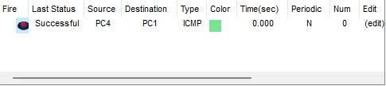

**Fig 6.1.1 MESSAGE PASSING TESTING SUCCESSFUL**

### **6.1.2 Ping Testing**

Ping testing in a network retail management system involves using the Ping utility to verify connectivity and measure the round-trip time (RTT) between network devices or hosts. It is a simple and commonly used method to test the reachability and response time of network components within the system. Use the Ping command-line utility or a network diagnostic tool to send ICMP (Internet Control Message Protocol) echo request packets to a specific IP address or hostname. The utility sends a request to the target device, which then responds with an echo reply if it is reachable and available.

It analyzes the ping results to determine whether the target device responded to the echo request. A successful ping indicates that the target device is reachable and that there is a network path between the source and destination. It measures the round-trip time (RTT), which is the time it takes for the echo request packet to reach the destination device and for the corresponding echo reply packet to return to the source device. The RTT value provides an indication of network latency and can help identify potential performance issues. It monitors the ping results for any packet loss. Packet loss occurs when the target device does not respond to one or more echo request packets. Consistent or significant packet loss can indicate network congestion, connectivity problems, or potential issues with the target device.

The two Pcs are connected via a ping command on the command prompt of any one Pc. The IP address of one PC is given on the command prompt of another PC. Then a message is sent to the PC which has that IP address. If the message is received from the PC successfully then a reply of zero percent information loss received the sender PC.

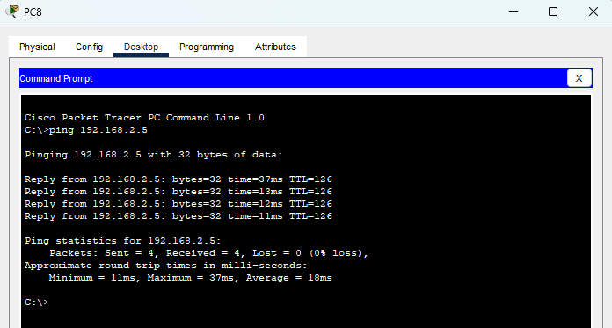

**Fig 6.1.2 PING TESTING SUCCESSFUL**

### **6.1.3 Firewall Protection**

Firewall protection testing in a network retail management system involves evaluating the effectiveness of the firewall in securing the system against unauthorized access, malicious attacks, and potential breaches. The objective is to ensure that the firewall is properly configured, rules are correctly implemented, and the system remains protected from potential security threats. Review and assess the firewall rules to verify that they are aligned with the system's security policies and requirements. It checks for any unnecessary or redundant rules and ensures that rules are properly defined, prioritized, and enforced. It tests the firewall's access control mechanisms by attempting to access the network or specific services from unauthorized sources or through unauthorized ports. It Verifies the firewall blocks unauthorized access attempts and allows only authorized traffic through. Conduct port scanning to identify open ports on the network. This helps ensure that only required ports are open, and any unnecessary or vulnerable ports are closed or blocked by the firewall.

In firewall protection access and message passing is prohibited. So that the above test cases of message passing and ping testing fail because it can't be able to transfer the messages between them and the test case failed due to enhanced firewall protection.

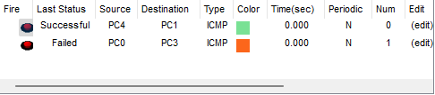

**Fig 6.1.3 FIREWALL TESTING SUCCESSFULL**



# SYSTEM IMPLEMENTATION

# **CHAPTER – 7**

## **SYSTEM IMPLEMENTATION**

Implementation is the process that transforms policies and plans into actions aimed at achieving strategic goals. It is a process, concept, idea, model, pattern or regulation for doing something. In this project we implemented two main modules, retail and vendor module. The retail module consists of four sub modules. They are centralized inventory management system, point-of-sale integration, customer relationship management, staff management system. The vendor module has two sub modules. They are web service module and client details module with a firewall protection. A lot of tasks must be done across different modules to be successful in an implementations process. centralized inventory management system control and governs and that consolidates and centralizes the management of inventory across multiple locations or channels within a retail business. Instead of maintaining separate inventory records for each location or channel, a centralized system provides a unified view and control over inventory, improving accuracy, efficiency, and decision-making. Point-of-sale monitors the sales information and stack details. Customer relationship management gathers and stores the complete data about customers. The web services provide dynamic web pages that update the information at a regular interval through the HTTP and DHCP protocols. A highly interactive web page is implemented in this system to which makes our system highly interactive with the users. FTP server is used to store and retrieve the required all files with proper authentication and protection. The whole system cost less than the already existing system with high efficiency.

# CONCLUSION AND FUTURE ENHANCEMENT

# **CHAPTER - 8**

**CONCLUSION AND FUTURE ENHANCEMENT**

## **8.1 CONCLUSION**

It is conclusively proven that our algorithm greatly exceeds that of the existing algorithms. The proposed method can also be extended by adding some more parameters which increases accuracy. The diffusion update algorithm offers several advantages in the system such as Scalability, Real-time Data Dissemination, Fault Tolerance, Consistency and Data Integrity, Reduced Network Traffic, Flexibility and Adaptability, Privacy and Security, Decentralization. In the previously existing system, the use of a greater number of servers and routers increases the cost of the system and makes the system more complex. In our proposed system we will reduce the cost and complexity that existed in the already existing system by decreasing the number of servers, routers and switches. Firewall protection to protect the customer details enhance the security of the system. In these ways our project proves its better features.

## **8.2 FUTURE ENHANCEMENT**

The future enhancements in a network retail management system can encompass various aspects to improve operational efficiency, customer experience, data analytics, and overall system performance. Integration of AI and ML technologies can enable advanced capabilities of the system. IoT devices can be employed to gather real-time data from various points within the retail network, such as RFID tags on products, smart shelves, or sensors in warehouses. Enhancements can be made to enable seamless integration of various sales channels, such as physical stores, e-commerce platforms, mobile apps, and social media. Enhancements in data analytics capabilities can provide retailers with deeper insights into customer behavior, market trends, and operational performance. Implementing advanced analytics algorithms, visual dashboards, and predictive modeling techniques can help retailers identify opportunities for revenue growth, optimize pricing strategies, and improve overall decision-making. In these ways the future technologies will contribute to the enhancement in network retail management.

# APPENDIX

# **APPENDIX A.1**

## **A.1 COMMANDS**

### **A.1.1 Router 0 (Fast ethernet 0/0) connection to switch 1 (Fast ethernet 0/1)**

Router>enable

Router#configure terminal

Enter configuration commands, one per line. End with CNTL/Z.

Router(config)#interface FastEthernet0/0

Router(config-if)#ip address 192.168.1.1 255.255.255.0

Router(config-if)#ip address 192.168.1.1 255.255.255.0

Router(config-if)#no shutdown

%LINK-5-CHANGED: Interface FastEthernet0/0, changed state to up

%LINEPROTO-5-UPDOWN: Line protocol on Interface FastEthernet0/0, changed state to up

### **A.1.2 Router 1 (Fast ethernet 0/0) connection to switch 2 (Fast ethernet 0/1)**

Router>enable

Router#configure terminal

Enter configuration commands, one per line. End with CNTL/Z.

Router(config)#interface FastEthernet0/0

Router(config-if)#ip address 192.168.2.1 255.255.255.0

Router(config-if)#ip address 192.168.2.1 255.255.255.0

Router(config-if)#no shutdown

%LINK-5-CHANGED: Interface FastEthernet0/0, changed state to up

%LINEPROTO-5-UPDOWN: Line protocol on Interface FastEthernet0/0, changed state to up

### **A.1.3 Router 0 connection to router 1 via serial 0/0/0**

Router>enable

Router#configure terminal

Enter configuration commands, one per line. End with CNTL/Z.

Router(config)#interface Serial0/0/0

Router(config-if)#ip address 192.168.3.1 255.255.255.0

Router(config-if)#ip address 192.168.3.1 255.255.255.0

Router(config-if)#no shutdown

Router(config-if)#

### **A.1.4 Router 0 connection to router 1 via serial 0/0/0**

Router>enable

Router#configure terminal

Enter configuration commands, one per line. End with CNTL/Z.

Router(config)#interface Serial0/0/0

Router(config-if)#ip address 192.168.3.2 255.255.255.0

Router(config-if)#ip address 192.168.3.2 255.255.255.0

Router(config-if)#no shutdown

Router(config-if)#

### **EIGRP Protocol in router 0**

Router>enable

Router#configure terminal

Enter configuration commands, one per line. End with CNTL/Z.

Router(config)#router eigrp 1

outer(config-router)#network 192.168.1.0 255.255.255.0

Router(config-router)#network 192.168.3.0 255.255.255.0

Router(config-router)#end

### **EIGRP Protocol in router 1**

Router>enable

Router#configure terminal

Enter configuration commands, one per line. End with CNTL/Z.

Router(config)#router eigrp 1

Router(config-router)#network 192.168.2.0 255.255.255.0

Router(config-router)#network 192.168.3.0 255.255.255.0

Router(config-router)#end

# **APPENDIX A.2**

## **A.2 SCREENSHOTS**

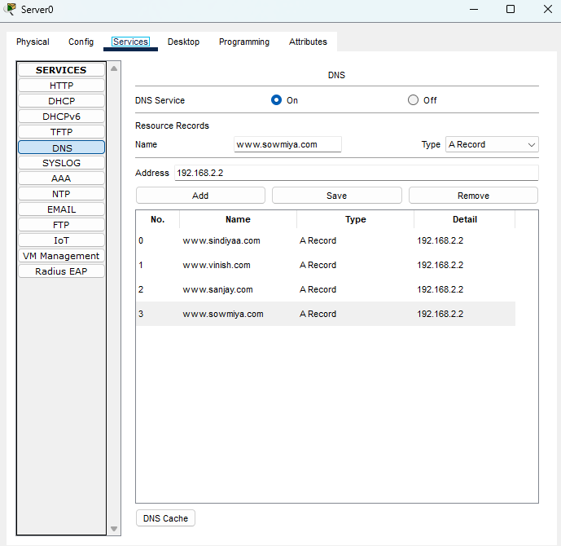

### **A.2.1 SERVER 0 DNS CONFIGURATION**

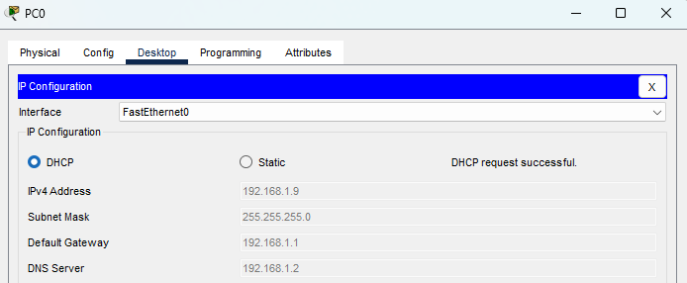

### **A.2.2 PC0 IP DHCP CONFIGURATION**

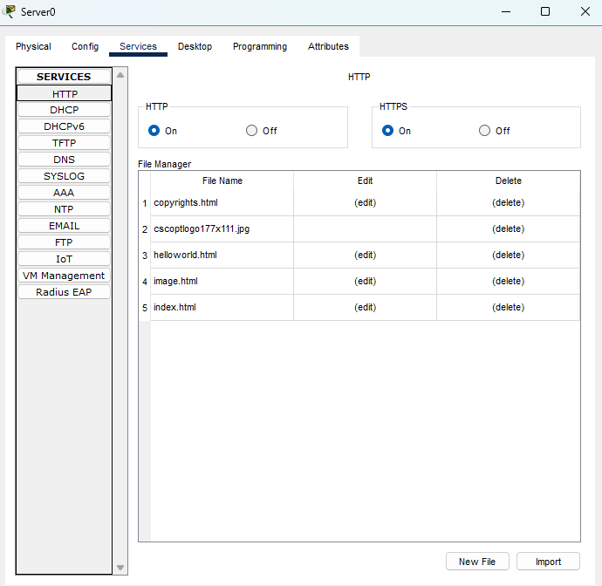

### **A.2.3 SERVER 0 HTTP CONFIGURATION**

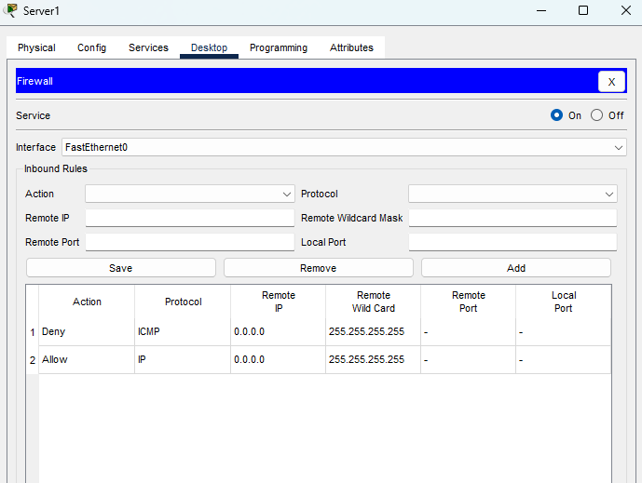

### **A.2.4 SERVER 1 FIREWALL PROTECTION**

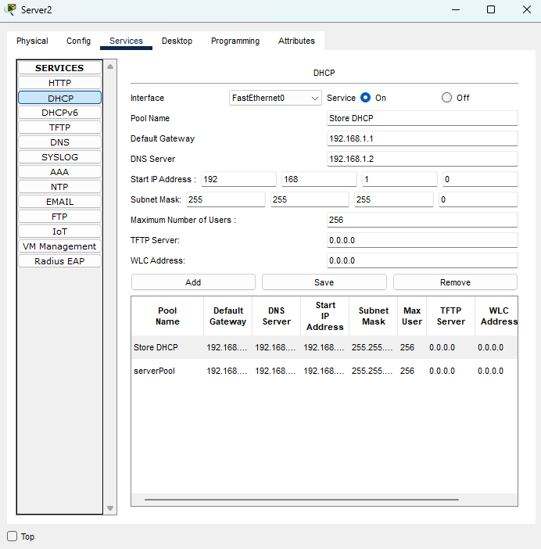

### **A.2.5 SERVER 2 DHCP CONFIGURATION**

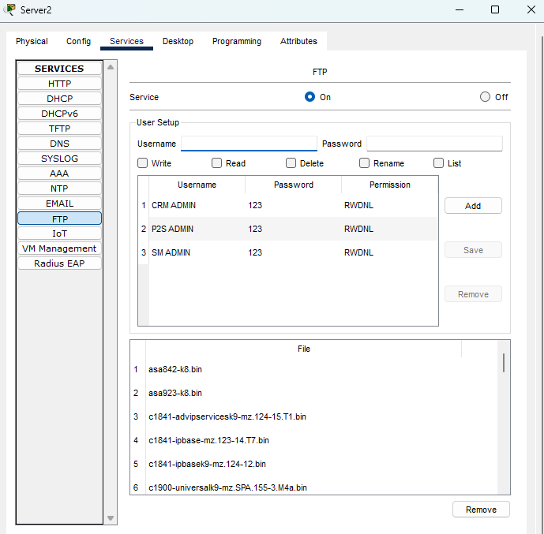

### **A.2.6 SERVER 2 FRP CONFIGURATION**

# REFERENCE



# **REFERENCE**

[1]. Packet tracer labs

<https://www.packettracerlab.com/how-to-connect-two-routers/#:~:text=We%20have%20to%20use%20a,other%20cable%20will%20not%20work.&text=Fast%20Ethernet%20connection%20can%20be,uses%20different%20types%20of%20connectors>. - accessed on - 15th May 2023

[2]. Tech Target

<https://www.techtarget.com/searchnetworking/definition/EIGRP#:~:text=Enhanced%20Interior%20Gateway%20Routing%20Protocol%20(EIGRP)%20is%20a%20network%20protocol,Border%20Gateway%20Protocol%20(BGP)>. – accessed on - 16th May 2023

[3]. Word press

<https://computernetworking747640215.wordpress.com/2019/11/22/how-to-configure-an-ftp-server-in-packet-tracer/> - accessed on - 16th May 2023

[4]. Geeks for geeks

<https://www.geeksforgeeks.org/dhcp-server-configuration-in-cisco/> - accessed on - 17th May 2023

[5]. IP Cisco

<https://ipcisco.com/lesson/dns-configuration-on-cisco-routers/> - accessed on – 18th May 2023

[6]. CISCO

<https://www.cisco.com/c/en/us/td/docs/ios-xml/ios/https/configuration/12-2sy/https-12-2sy-book/nm-http-web.html> - accessed on - 18th May 2023